# Software Review Report

## Quality Assurance & Control

During the development process, we developed a test plan which was then put into motion during the testing phase to counter foreseeable issues during development. We also tested extensively during the development phase to ensure our code and design were functioning as intended.

## Code Testing

The code testing in the testing phase was performed according to this structure:

1. Select a test case detailed in the testing plan.
2. Perform the test defined in the testing plan.
3. Compare the expected and actual results of the test.
4. Adjust the code if the test failed and repeat, OR
5. Take a screenshot as evidence if the test succeeded.

## Support for future development

If future modification is required, we are confident in our ability to extend our current code with further requirements.

* Appropriate comments are applied to our PHP code, but not our HTML code.
* Code is not well documented, as it might be using a documentation generator utility. If the scope of the project ever increases in the future, we may consider adding this kind of documentation. For the current scale of the project, we believe commenting will suffice for code documentation.
* We will be able to append new requirements and sprints to our documentation painlessly. This will consist of:
  + Adding a new project Kanban board to the project GitHub page.
  + Creating new requirements and testing documentation for the new sprint.
  + Appending the new documentation to the master document.

## Provide a mapping of the user requirement to the final software product (did you meet the clients expectations and requirements).

|  |  |
| --- | --- |
| User Requirements | Solution |
| Multi-platform report | We design the application using responsive approach which is more user friendly and SEO friendly. |
| Adapt prototype to responsive approach | In order to implement responsive approach to our website we utilize bootstrap. |
| Implement membership page | We implemented a form to capture people email and whether or not they want newsletter or newsflash notification. Figure 1 |
| Implement an option to remove subscription | We implemented a way for the employee to remove people from their newsletter or newsflash notification option. Figure 2 |
| Implement a password system for employee | To improve the security of the client database we have implemented a login system for employee. Figure 3 |
| Implement an admin system to update employee password | We implemented an admin system to update employee password. Figure 4 and 5 |
| Implement a rating system | We implemented a rating system which the user can rate the movie they like. Figure 6 |
| Implement streaming table | In order to keep the top 10 table updated we have implemented an auto refresh feature. |

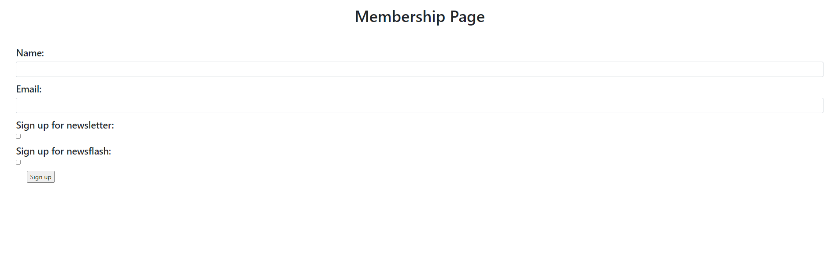

Figure 1

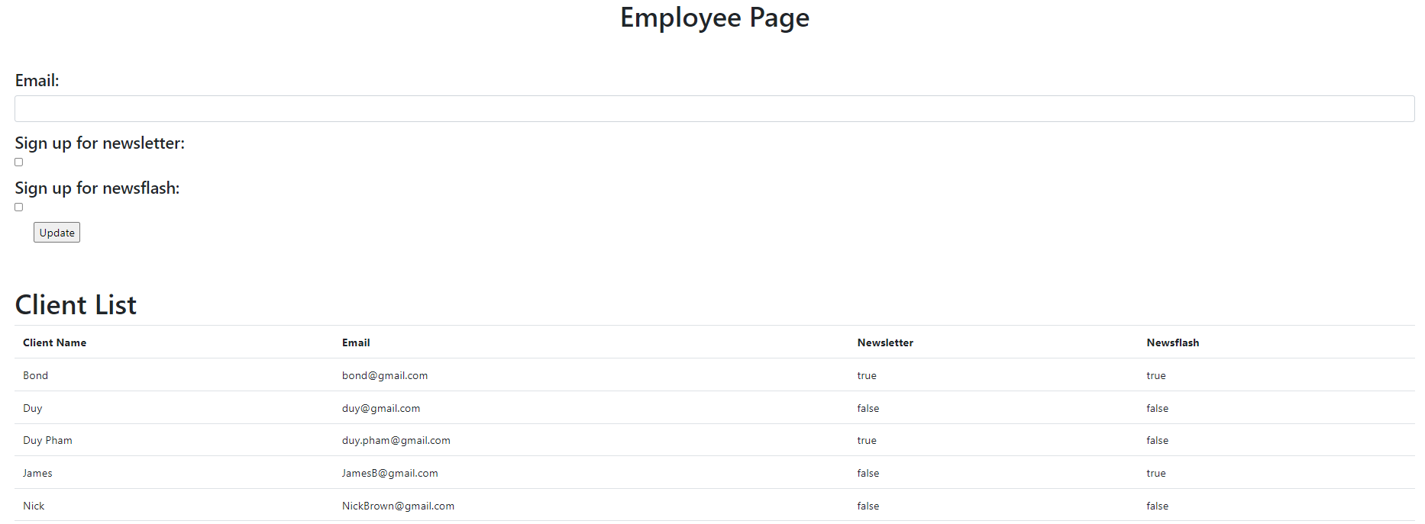

Figure 2

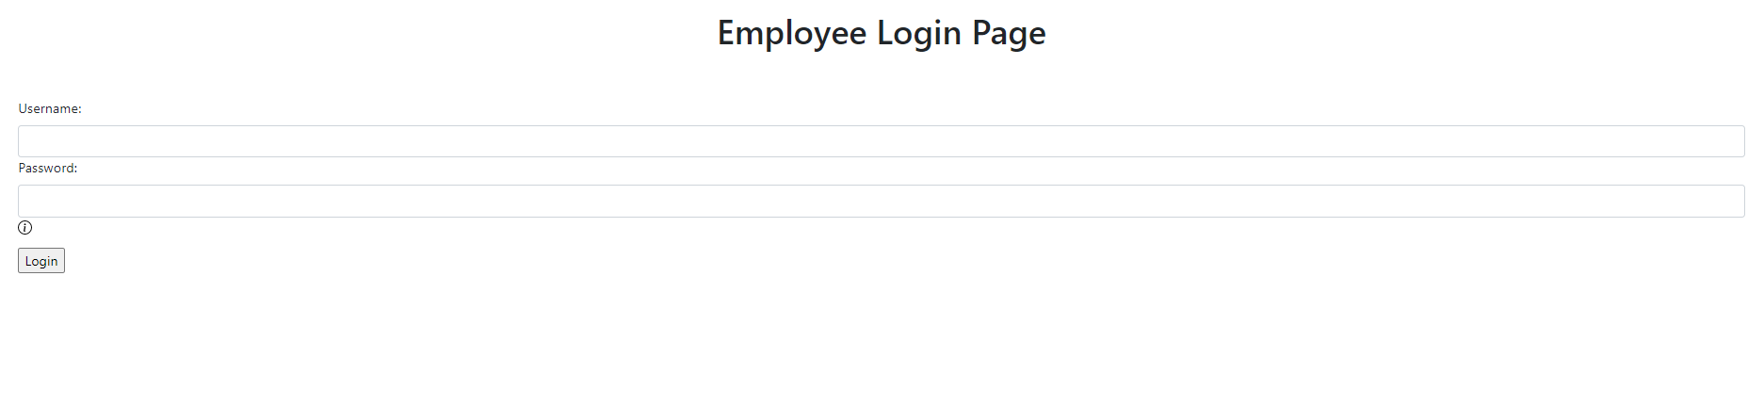

Figure 3

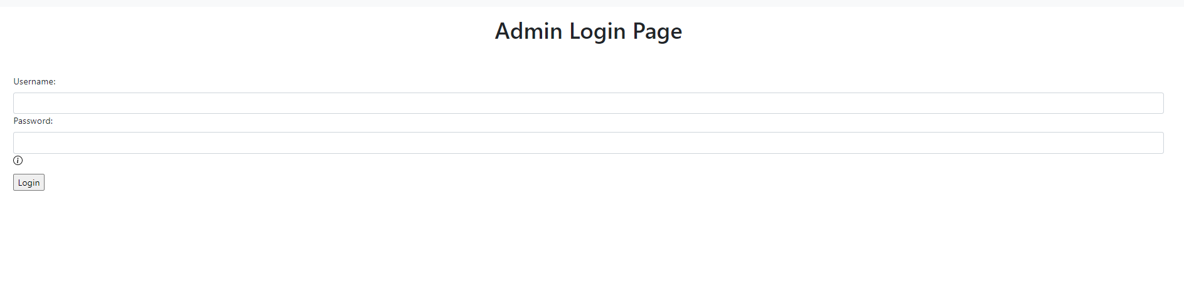

Figure 4 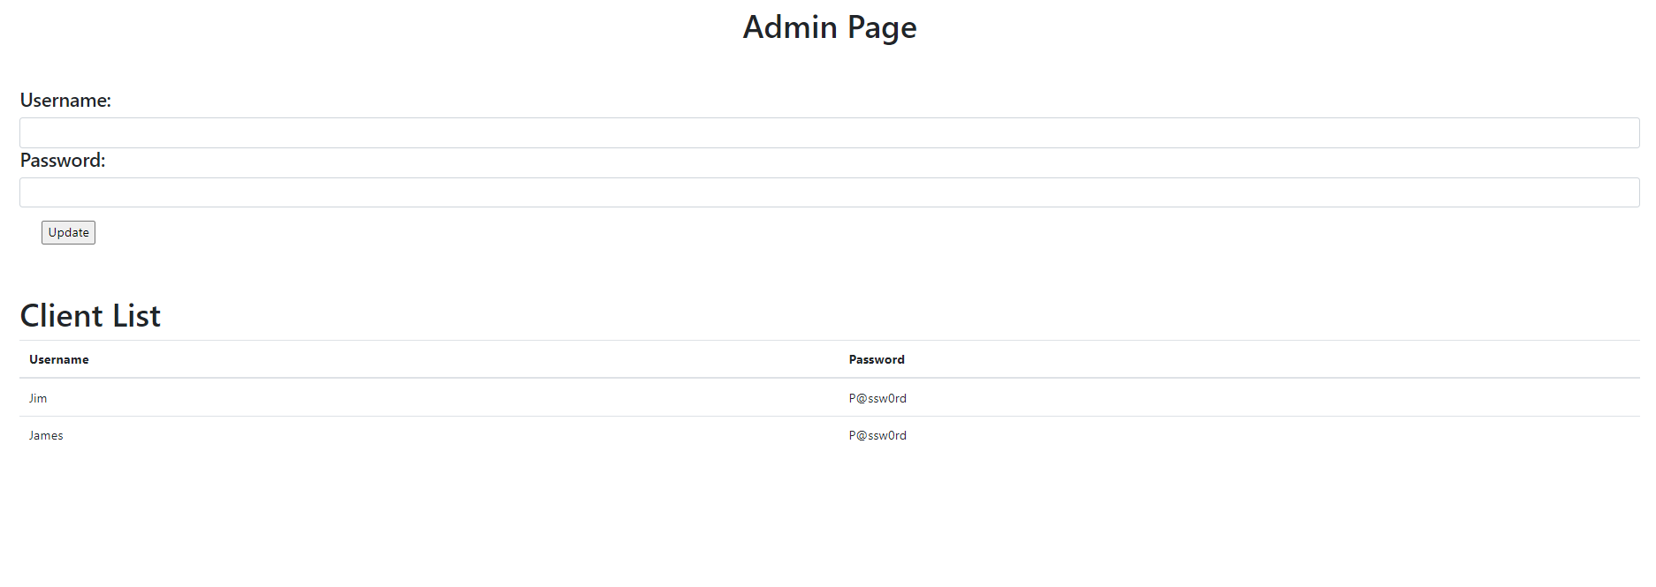

Figure 5



Figure 6